**CHAPTER 1**

**INTRODUCTION**

The Blood Bank Management System is a pivotal software solution designed to enhance the efficiency and accessibility of blood donation processes within the context of India. This system addresses the critical need for organized blood donation management. By leveraging modern web technologies, the system aims to bridge the gap between blood donors and recipients, ensuring a streamlined and responsive network across various locations in the country.

**1.1** **OVERVIEW**

This comprehensive system comprises two main sections: the admin section and the user section. The admin section empowers administrators with tools for editing, updating, and managing donors, blood requests, and locations. On the other hand, the user section caters to individuals interested in contributing as donors or seeking blood assistance, providing them with a user-friendly platform to interact with the system seamlessly. The design philosophy revolves around simplicity to guarantee user-friendliness, reducing barriers for both administrators and users. This simplicity ensures that individuals navigating the system encounter minimal challenges, fostering a positive and effective user experience.

## **1.2 OBJECTIVES**

The objective of a blood donation project is typically to encourage and facilitate the voluntary donation of blood from eligible donors for the purpose of ensuring a safe and sufficient blood supply. The specific goals and objectives may vary based on the scope and nature of the project, but common objectives include:

**1.2.1**  **Efficient Donor Management:** Enable administrators to efficiently manage donor information, ensuring accuracy and completeness of donor profiles.

**1.2.2 Timely Blood Request Handling:** Facilitate quick and effective handling of blood requests, connecting donors with recipients in a timely manner.

**1.2.3. User-Friendly Interface:** Prioritize a simple and user-friendly design to enhance accessibility, ensuring that users, both administrators and individuals seeking blood, can navigate the system with ease.

**1.2.4. Location Flexibility:** Provide administrators with the ability to edit and manage locations, adapting the system to changing requirements and ensuring coverage across various regions in India.

**1.2.5.** **Streamlined Processes:** Streamline the blood donation process for users, allowing easy donor registration and blood request submissions.

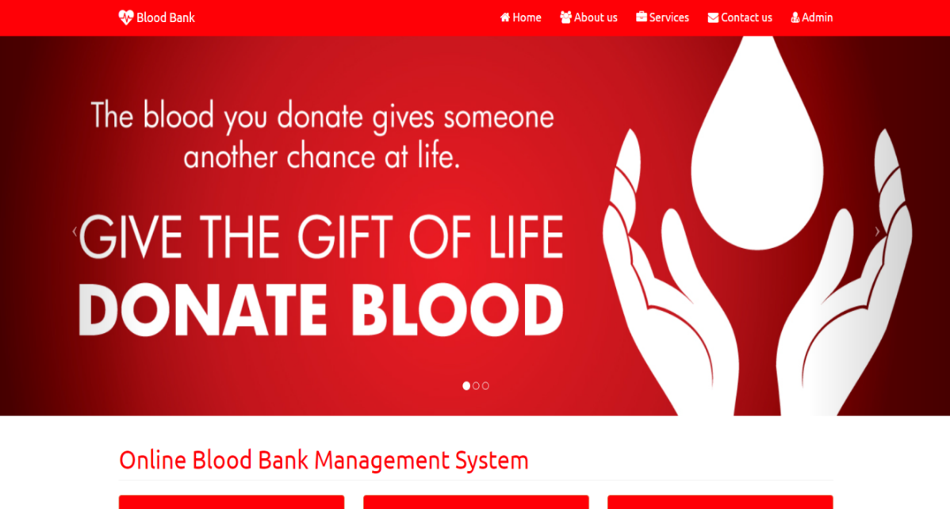

**Fig. 1.1 Home Page**

## **1.3 KEY FEATURES**

Key features of a blood donation project include elements and strategies designed to achieve the project's objectives effectively. Here are some essential features:

**1.3.1. Admin Section:**

* **Editing and Updating:** The admin section allows seamless editing and updating functionalities, ensuring accurate and up-to-date information regarding donors, blood requests, and locations.
* **Donor Management**: Efficient management of donors, including their profiles, donation history, and contact details, is a key feature.
* **Blood Request Handling:** Admins can handle incoming blood requests, ensuring timely responses and coordination between donors and recipients.
* **Location Editing:** The system enables the admin to edit and manage locations, facilitating flexibility in adapting to changing requirement.

**1.3.2. User Section:**

* **User-Friendly Design:** The system boasts a simple design to enhance user experience, minimizing potential difficulties during interaction.
* **Donor Registration:** Users can easily register as blood donors, providing necessary information to become part of the blood donation network.
* **Blood Request Submission:** Individuals in need of blood can submit requests through the user section, initiating a streamlined process for assistance.

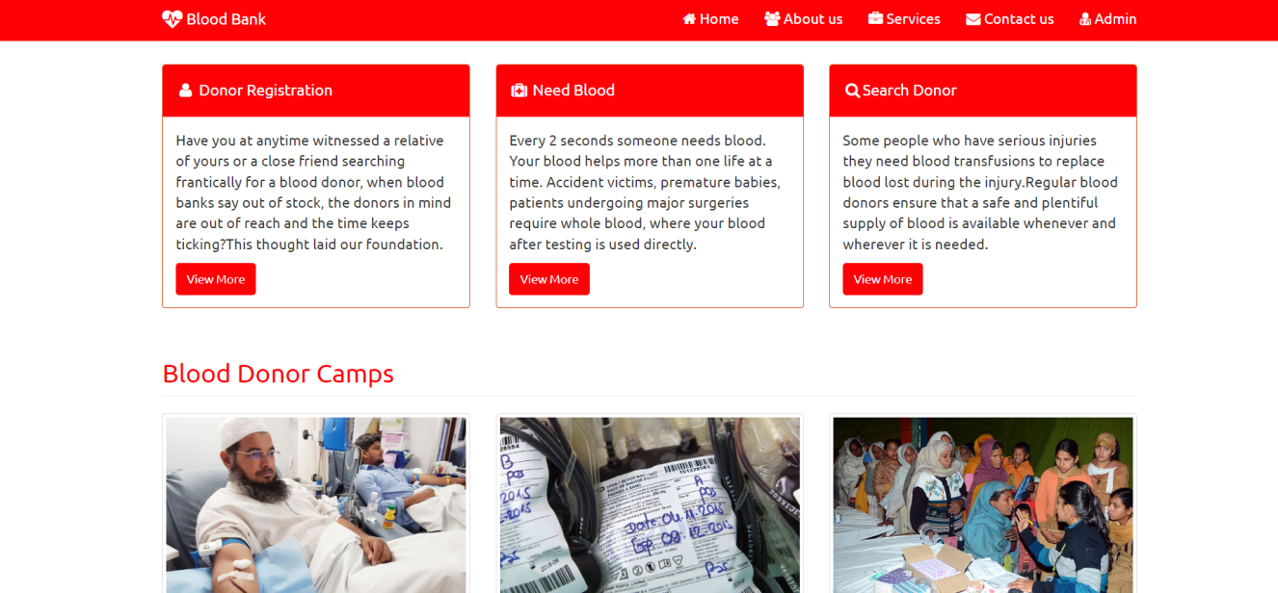

**Fig. 1.2 Select Role**

## **1.4 HARDWARE / SOFTWARE USED IN PROJECT**

The Blood Donation will involve a combination of hardware and software components to ensure its development, deployment and functionality. Here is detailed List:

**1.4.1 Server-side Hardware:**

**1. RAM (Random Access Memory):**

* 8GB to 16GB (for moderate-sized application and user load).
* Consider higher capacities (e.g., 32GB or more) for scalability and handling a large number of concurrent users.

**2. ROM (Storage):**

* SSD storage for faster read and write operations.
* Allocate storage based on the application codebase, database size, and media storage requirements.

**3. Processor:**

* Multi-core processor (quad-core or higher) for efficient handling of concurrent user requests.

**4. Operating System:**

* Linux-based operating system (e.g., Ubuntu Server, CentOS, Debian) for stability and performance.

**5. Network Equipment:**

* Network infrastructure to facilitate secure data transfer between users and the server.

**1.4.2 Database Server:**

**1. RAM:**

* 16GB or more for efficient handling of concurrent database queries.

**2. ROM(Storage):**

* SSD storage for faster data retrieval.
* Allocate storage based on the anticipated size of the database and data storage needs.

**3. Processor:**

* Multi-core processor with sufficient processing power for complex database operations.

**4. Operating System:**

* Windows operating system for the database server.

**1.4.3 User Devices:**

**1. Smartphones/Tablets:**

* Compatibility with iOS and Android operating systems.
* Optimization for various screen sizes and resolutions.

**2. Web Browsers:**

* Compatibility with major web browsers such as Google Chrome, Mozilla Firefox, Safari, and Microsoft Edge.

**1.4.4 Development Environment:**

**1. Programming Languages:**

* Backend: PHP language.
* Frontend: HTML, CSS, JavaScript.

**2. Framework:**

* Web application framework

**3. Database Management System:**

* Choose a suitable DBMS (e.g., MySQL, PostgreSQL, MongoDB) for efficient data storage and retrieval.

**4. APIs:**

* Develop APIs to enable communication between the frontend and backend components.

**5. Integrated Development Environment (IDE):**

* IDEs such as Visual Studio Code, PyCharm, or IntelliJ IDEA for coding and debugging.

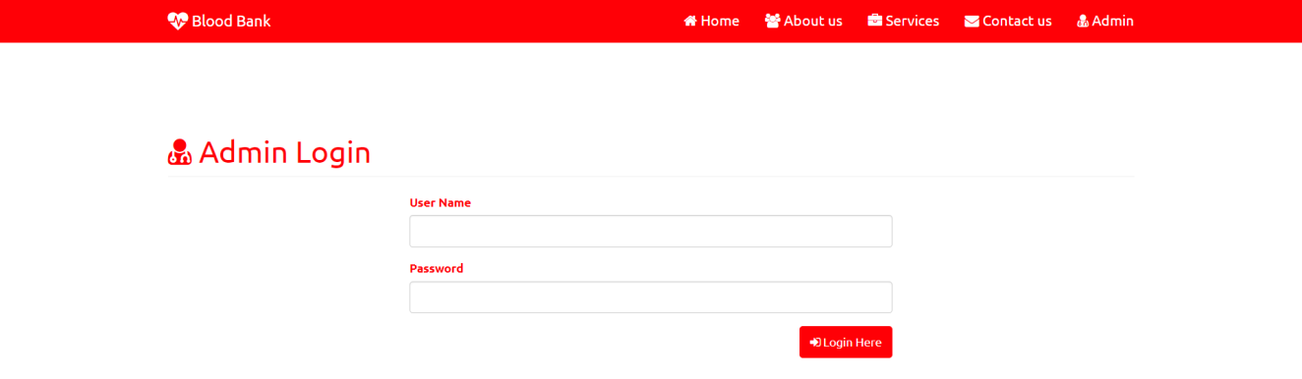

**Fig. 1.3 Login Web Page**

**CHAPTER 2**

**FEASIBILITY STUDY**

Blood donation is a life-saving and altruistic act that plays a pivotal role in healthcare systems worldwide. Recognizing the critical importance of a sustainable and efficient blood supply, [Your Organization/Community Name] is considering the implementation of a blood donation project. This feasibility study aims to assess the viability and practicality of such an initiative, exploring key aspects such as economic, technical, operational, scheduling, and legal considerations.

In recent years, the demand for blood and blood products has seen a steady rise due to various factors, including an aging population, increased prevalence of chronic diseases, and a growing need for advanced medical treatments. Despite the critical need for a stable blood supply, many regions face challenges related to donor recruitment, retention, and the overall organization of blood donation drives.

* 1. **KEY OBJECTIVES**
     1. **Technical Feasibility**:
* Introduction: Technical feasibility assesses the practicality of implementing the blood donation project from a technological perspective. It involves evaluating whether the required technology and infrastructure are available, accessible, and compatible.
* Considerations: This includes the examination of hardware, software, network capabilities, and any other technical resources needed for the project. It ensures that the chosen technology can support the project's objectives efficiently.
  + 1. **Economic Feasibility**:
* Introduction: Economic feasibility examines the financial viability of the blood donation project. It assesses whether the project is financially sound, considering costs, benefits, and potential returns on investment.
* Considerations: This involves analyzing the budget, fundraising opportunities, and estimating the long-term economic impact. It evaluates whether the project aligns with the available financial resources and if it can sustain itself economically.
  + 1. **Legal Feasibility**:
* Introduction: Economic feasibility examines the financial viability of the blood donation project. It assesses whether the project is financially sound, considering costs, benefits, and potential returns on investment.
* Considerations: This involves analyzing the budget, fundraising opportunities, and estimating the long-term economic impact. It evaluates whether the project aligns with the available financial resources and if it can sustain itself economically.
  + 1. **Operational Feasibility**:
* Introduction: Economic feasibility examines the financial viability of the blood donation project. It assesses whether the project is financially sound, considering costs, benefits, and potential returns on investment.
* Considerations: This involves analyzing the budget, fundraising opportunities, and estimating the long-term economic impact. It evaluates whether the project aligns with the available financial resources and if it can sustain itself economically.
  + 1. **Scheduling Feasibility**:
* Introduction: Scheduling feasibility involves evaluating whether the blood donation project can be completed within the specified time frame. It assesses the project timeline, milestones, and critical path activities.
* Considerations: This includes developing a realistic project schedule, identifying potential bottlenecks, and ensuring that deadlines are achievable. It helps in planning and managing the project's timeline effectively.

**2.2 Technical Feasibility**

* Introduction: Technical feasibility assesses the practicality of implementing the blood donation project from a technological perspective. It involves evaluating whether the required technology and infrastructure are available, accessible, and compatible.
* Considerations: This includes the examination of hardware, software, network capabilities, and any other technical resources needed for the project. It ensures that the chosen technology can support the project's objectives efficiently.

**2.2.1 Infrastructure Requirements:**

* **Server Infrastructure:** Asses the capacity and scalability of cloud-based servers (e.g., AWS, Azure) to accommodate potential user growth and ensure seamless performance.
* **Database Management**: Evaluate the suitability of database systems (e.g., MySQL, PostgreSQL) for efficient storage and retrieval of user data.

**2.2.2 Software Development:**

* **Programming Languages:** Choose appropriate backend (e.g., PHP) and frontend (e.g., HTML, CSS, JAVASCRIPT) technologies based on developer expertise and project requirements.
* **Framework Selection**: Select a web application framework (e.g., Django, Flask) to streamline development and enhance maintainability.

**2.2.3 Security Measures:**

* **Authentication Protocols:** Implement secure authentication mechanisms to protect user accounts and ensure data security.

**2.3 Operational Feasibility**

* Introduction: Economic feasibility examines the financial viability of the blood donation project. It assesses whether the project is financially sound, considering costs, benefits, and potential returns on investment.
* Considerations: This involves analyzing the budget, fundraising opportunities, and estimating the long-term economic impact. It evaluates whether the project aligns with the available financial resources and if it can sustain itself economically.

**2.4 Behavioral Feasibility**

In the realm of healthcare initiatives, the behavioral feasibility of a blood donation project plays a pivotal role in its ultimate success. A blood donation project, while rooted in the noble cause of saving lives, is inherently tied to the willingness of individuals to participate actively. Behavioral feasibility delves into understanding the attitudes, perceptions, and motivations of potential donors, as well as the broader community, toward blood donation.

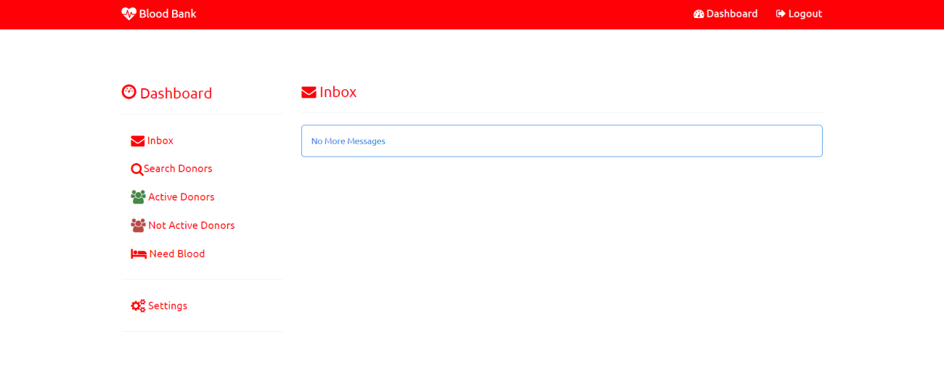

**Fig. 2.1 Behavioral Dashboard**

**2.5 Schedule Feasibility**

The successful execution of a blood donation project is contingent upon meticulous planning and adherence to a well-structured schedule. Schedule feasibility involves evaluating the project's timeline, milestones, and critical activities to ensure that the objectives are achieved within the allocated time frame.

The following factors contribute to the schedule feasibility of a blood donation project:

* + Planning Phase: Initiation of the project involves defining goals, objectives, and scope. Formation of a project team with clearly defined roles and responsibilities. Conducting a comprehensive needs assessment to identify target demographics and potential challenges.
  + Regulatory Approvals: Ensuring compliance with local, regional, and national regulations related to blood donation activities. Obtaining necessary permits and approvals from health authorities and regulatory bodies.
  + Resource Allocation: Identifying and securing necessary resources, including personnel, medical equipment, and transportation. Allocating budgetary resources for promotional campaigns, educational materials, and donor incentives.

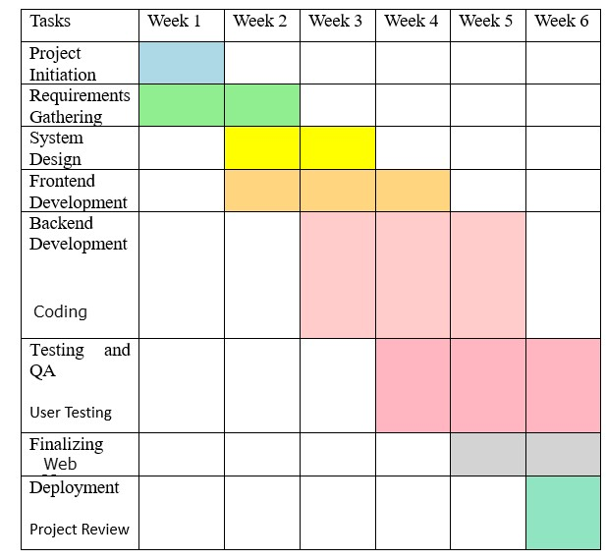

**Fig. 2.2 Schedule Feasibility (Gantt Chart)**

**CHAPTER 3**

**DATABASE DESIGN**

In the context of a blood donation project, a well-designed database plays a crucial role in efficiently managing, storing, and retrieving information related to donors, recipients, blood inventory, and other essential aspects. The goal of the database is to ensure accurate, secure, and timely access to information that is vital for the success of the blood donation program. Here's an introductory overview of the database design for such a project.

The primary purpose of the database is to streamline the entire blood donation process, from donor registration and eligibility checks to inventory management and recipient matching. It serves as a central repository for all relevant data, facilitating quick and reliable information retrieval.

* 1. **DATABASE TABLES**

Creating a comprehensive database table for the Share Expense app involves

considering the key entities and their attributes. In a simplified example, let's focus on two main entities: Users and Expenses. Here's a basic representation:

* + 1. **Donor Table:**
* **user_id (Primary Key):** Unique identifier for each user.
* **email:** User’s email address for communicate and login.
* **name:** User’s full name.
* **password_hash:** Securely hashed password for authentication.
* **phone number:** User’s contact number.
* **gender:** User’s gender

|  |  |  |  |  |  |
| --- | --- | --- | --- | --- | --- |
| **User_Id** | **Email** | **Name** | **Password_Hash** | **Phone Number** | **Gender** |
| 1 | abc@gmail.com | Salman | #2122223fsdx | 9368563111 | Male |
| 2 | [a@gmail.com](mailto:a@gmail.com) | Abhir | #3c2223rsdx | 8321123885 | Male |
| 3 | xyz@gmail.com | Raj | #2122253ftdx | 9462533885 | Male |

**Tab. 3.1. Donor Table**

* + 1. **Request Blood Table:**
* **Name**
* **Gender**
* **Blood Type**
* **Email**
* **Contact**
* **Pin**

|  |  |  |  |
| --- | --- | --- | --- |
| **Name** | **Blood Type** | **Email** | **Pin** |
| Raj Kumar | A+ | xyz@.com | 201206 |
| Shivam | O+ | pqr@.com | 301306 |
| Ajay | O- | fcgvg@.com | 201206 |

**Table 3.2. User’s Blood Request Table**

**3.2 FLOWCHART**

This introduction to the flowchart provides an overview of the major steps involved in a blood donation project, from initiation to project assessment. Depending on the complexity and specific goals of your project, you can customize and expand upon these steps as needed.

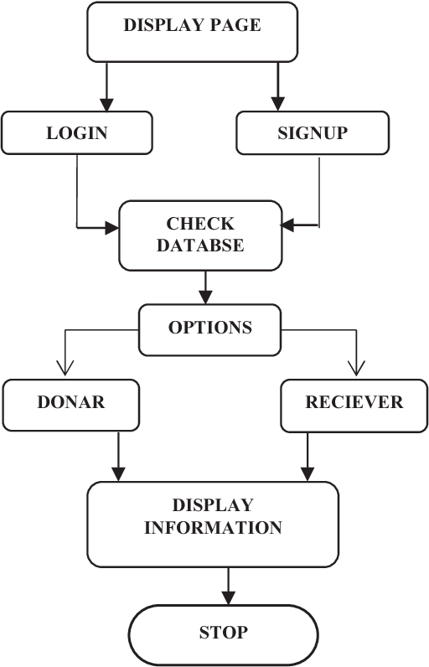

**Fig. 3.3 Flowchart Diagram**

* 1. **USE CASE DIAGRAM**

This Use Case Diagram is a graphic depiction of the interactions among the elements of Blood Bank Management System. It represents the methodol- ogy used in system analysis to identify, clarify, and organize system requirements of Blood Bank Management System. The main actors of Blood Bank Management System in this Use Case Diagram are: Super Admin, System User, Donor, Anonymous Users, who perform the different type of use cases such as Manage Blood, Manage Blood Group, Manage Blood cells, Manage Donor, Manage Stock, Manage Order, Manage Patient, Manage Users and Full Blood Bank Management System Operations. Major elements of the UML use case diagram of Blood Bank Management System are shown on the picture below.

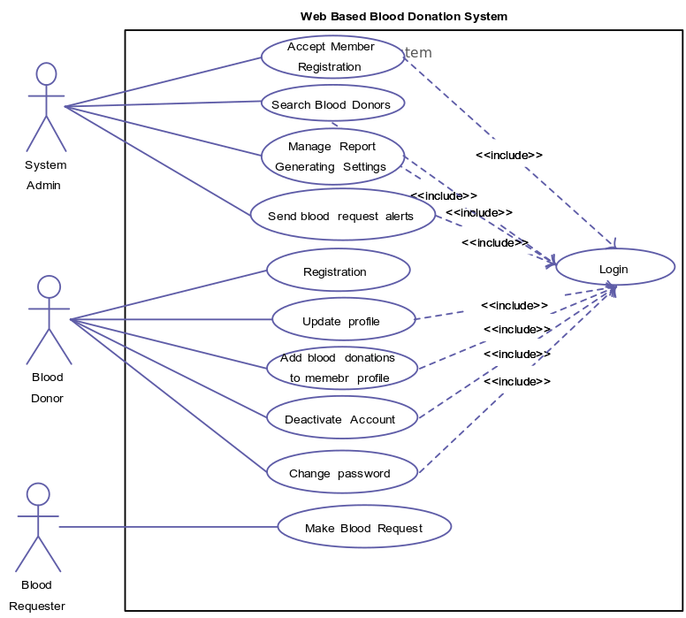

**Fig. 3.4 Use Case Diagram 1**

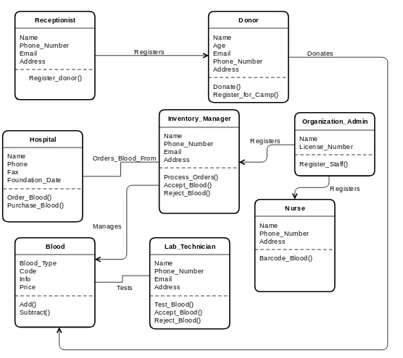

**Fig. 3.5 Use Case diagram 2**

* + 1. **Actors:**
* User
* System
  + 1. **Use Case**
* Select Mode
* Login
* Forgot Password
* Reset Password
* Sign Up
* Verify Email
* Open Dashboard
  1. **DATA FLOW DIAGRAM**

**3.4.1 Blood Bank Management System DFD Level 0**

To start with, let us familiarize what is Blood Bank Management System DFD level 0. The Blood Bank Management System DFD level 0 is also known as context diagram. It's supposed to be an abstract view, with the mechanism represented as a single process with external parties. This DFD for the Blood Bank Management System depicts the overall structure as a single bubble. It comes with incoming/outgoing indicators showing input and output data.



**Fig. 3.6 Level 0 DFD**

In this data flow diagram, you will see the general process done in Blood Bank Management System monitoring. This will also serve as a guide as you go through the deeper processes of the Blood Bank Management System data flow diagrams. As you see, when you build the levels of data flow diagrams, the connections of the transactions and data also broadens and gets more specific.

**3.4.2 Blood Bank Management System DFD Level 1**

Next to the context diagram is the level 1 data flow diagram. The content of Blood Bank Management System DFD level 1 must be single process node from the context diagram and is broken down into sub processes.

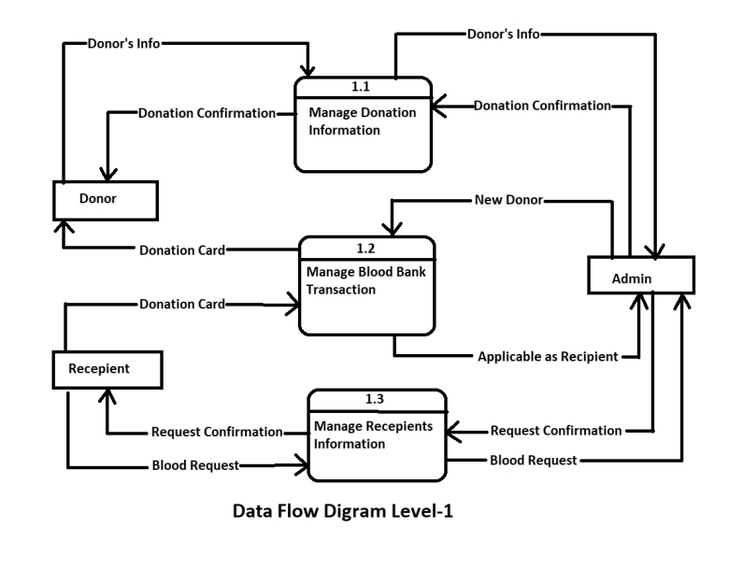

**Fig. 3.7 Level 1 DFD**

In this level, the system must display or reveal further processing information.

The following are essential data to accommodate:

• Blood Bank Records

• Donors Records

• Donation Records

• Donation Request

• Donors Information

These procedures require information such as record of donors, donations, transactions and blood bank from which served as the bases for the bloodletting or blood bank admin to manage the Blood Bank Management System. This type of data is represented by a data store. With being knowledgeable about the DFD level 1 of the Blood Bank Management System, you will know then its broaden context terms. In addition to that, this may also serve as your reference on how the inputs or data fed on the system. Then you will be also informed about the outputs that the system gives.

These processes shown in the DFD were all based on the concept of Blood Bank Management System.

**3.4.3** **Blood Bank Management System Level 2**

After presenting the Blood Bank Management System DFD levels 0 and 1, next to that is level 2.

Here's what you need to consider in creating data flow diagram level 2 for Blood Bank Management System.

• The Level 2 DFD for the system should represent the basic modules as well as data flow between them.

• Since the DFD level 2 is the highest abstraction level, its Blood Bank Management System processes must be detailed that is based on the DFD level 1.

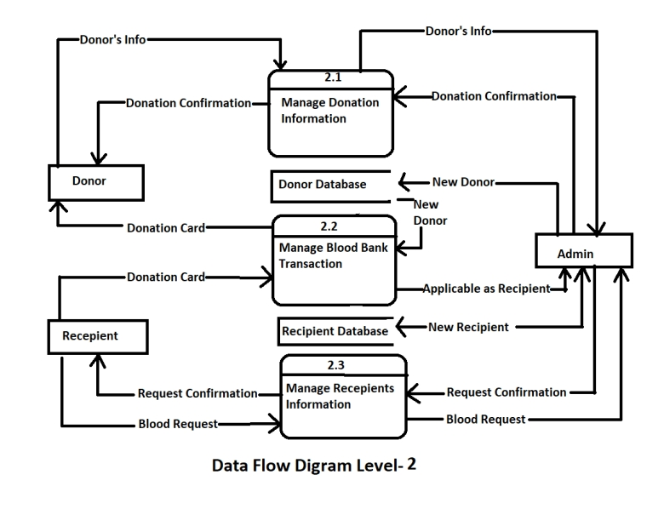

**Fig. 3.8 Level 2 DFD**

Finally, after figuring the processes given in the system, the user will now have their request being processed.

The Processes that the system should prioritize are as follows:

• Manage Donors' Information

• Manage Blood Donation Information

• Checks Donors' Health Status

• Monitor Donation Transactions

• Manage Blood Donation

Transactions DFD level 2 lets you know the ideas on where does the data inputs goes and inputs comes within the Blood Bank Management System. Considering the the dataflow levels mentioned above, you can determine well the importance of breaking the processes into more specific manner.

The presented level not only shows you the detailed processes of system, but also gives you precise destination of the data that flows in the system.

This DFD will also be your references as you make and design your own project DFD levels 0, 1 and 2.

* 1. **ER-DIAGRAM**

An Entity-Relationship (ER) diagram for a blood donation project would depict the various entities involved in the system and their relationships. Here's a brief outline of what such a diagram might include:

**Entities:**

* **Donor:** Represents individuals willing to donate blood. Attributes could include donor ID, name, contact information, blood type, etc.
* **Blood Bank:** Represents locations where donated blood is stored and managed. Attributes could include bank ID, location, contact information, etc.
* **Blood Donation:** Represents the act of donating blood. Attributes might include donation ID, donor ID, donation date, blood type donated, etc.
* **Blood Transfusion:** Represents the process of transferring blood from a donor to a recipient. Attributes could include transfusion ID, donor ID, recipient ID, transfusion date, etc.

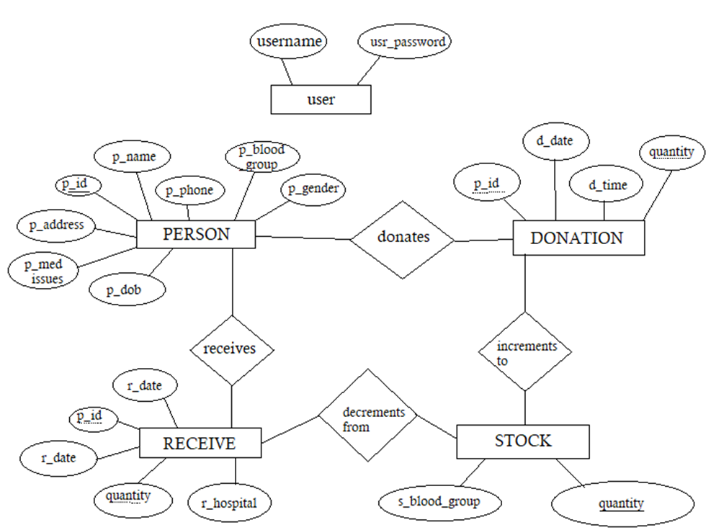

**Fig. 3.9 ER-Diagram 1**

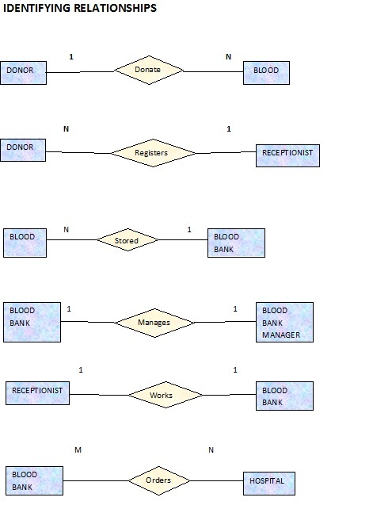

**Fig. 3.10 ER-Diagram 2**

* 1. **ACTIVITY DIAGRAM**

The activity diagram provides a clear visualization of the blood donation process, helping to streamline operations and ensure efficient coordination between donors, recipients, and the organization facilitating the donations.

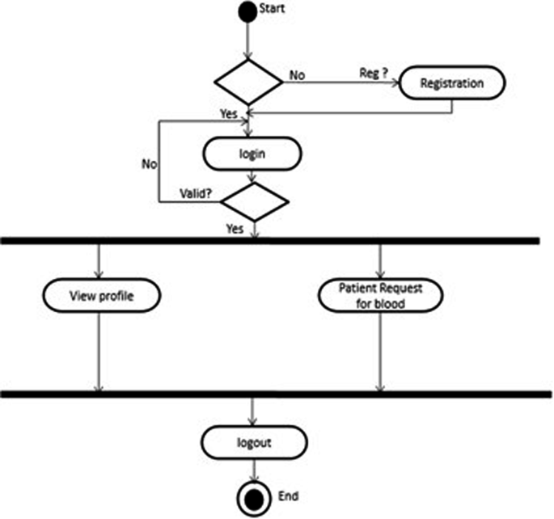

**Fig. 3.11 Activity Diagram**

**CHAPTER 4**

**PROJECT PROCESS**

The form design for the Blood Donation Project aims to provide a user-friendly and efficient interface for capturing, managing, and processing essential information related to blood donation activities. These forms play a pivotal role in engaging donors, organizers, healthcare professionals, and administrators, ensuring smooth data flow and effective project management.

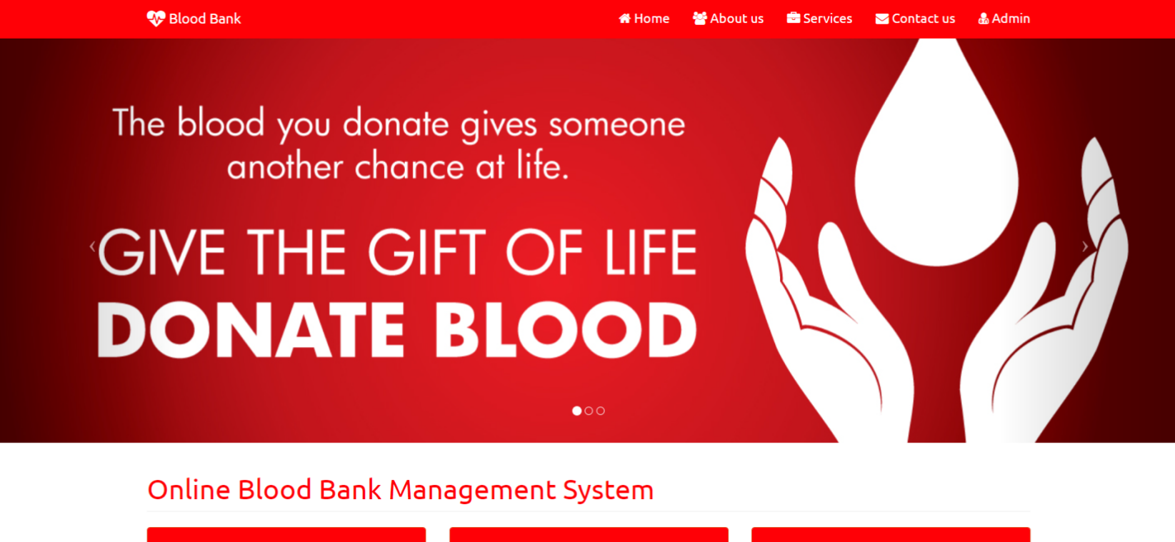

**Fig. 4.1: Home Page**

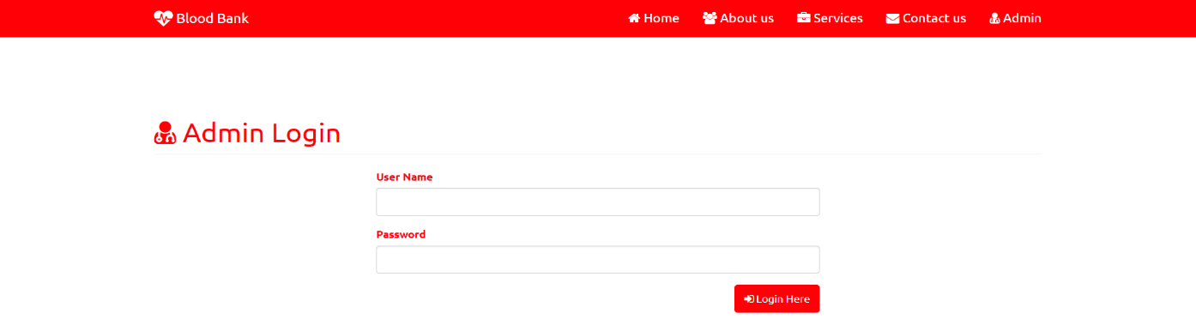

**Fig. 4.2 Users/Admin login form**

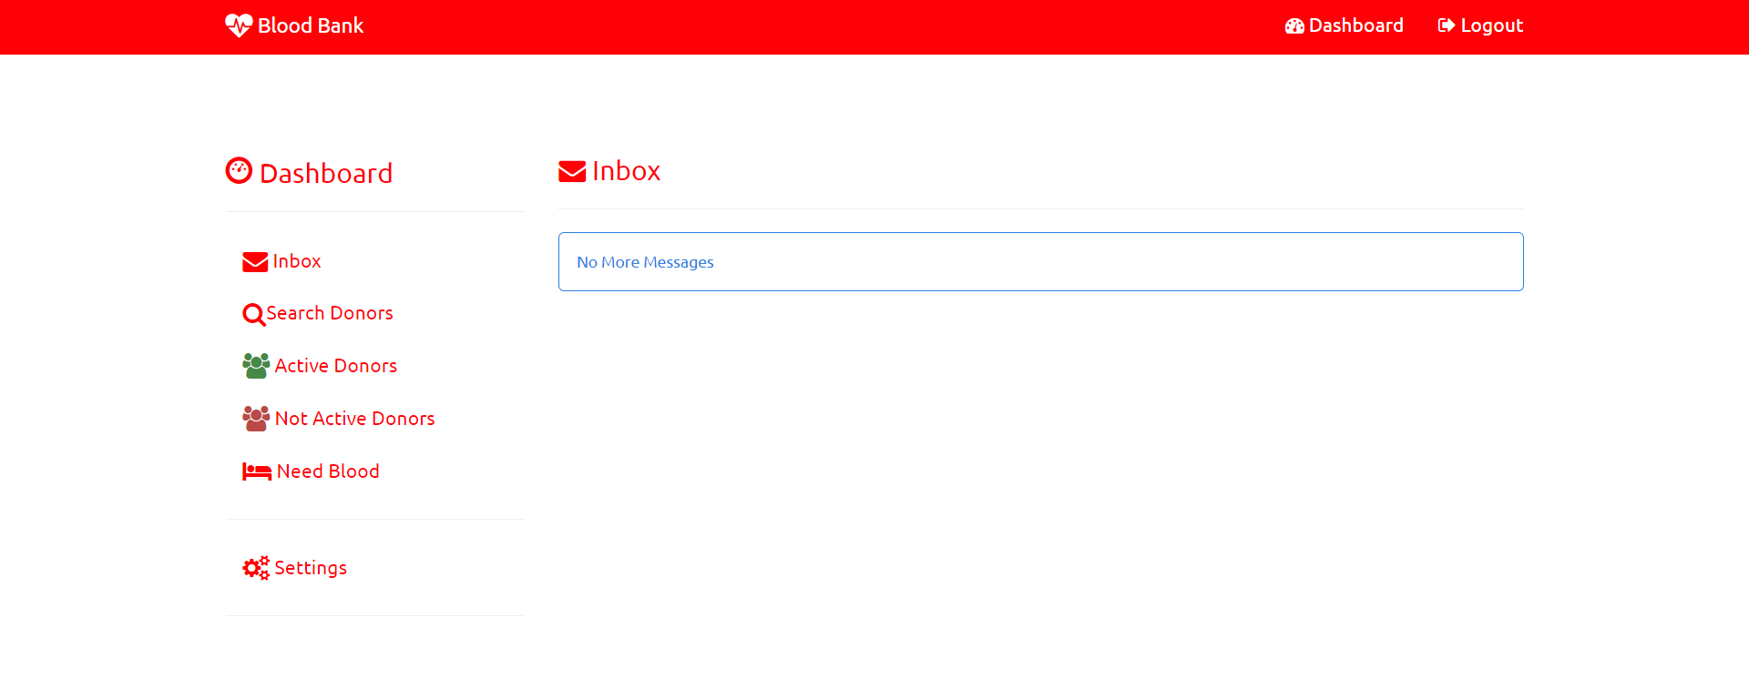**Fig. 4.3: Admin Home Page**

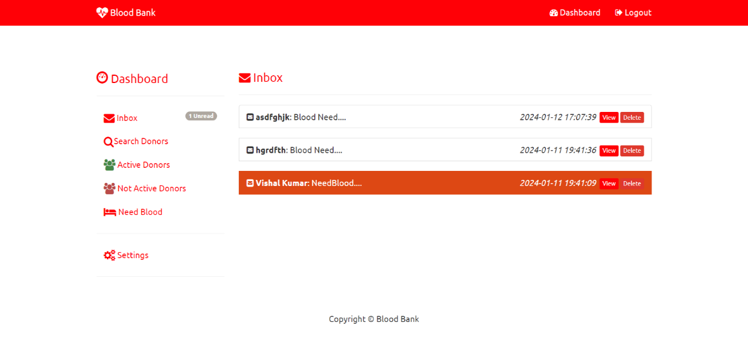

**Fig. 4.4: Inbox Page**

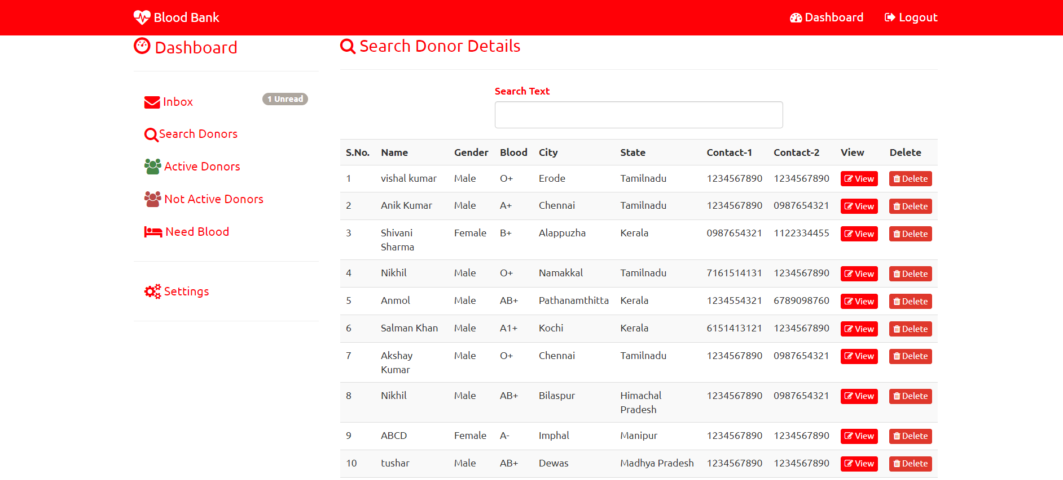

**Fig. 4.5: Search Donor Page**

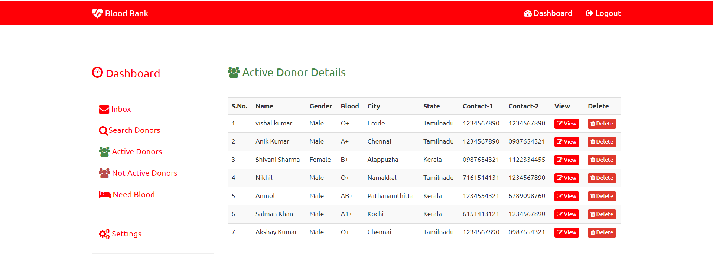

**Fig. 4.6: Active Donor Page**

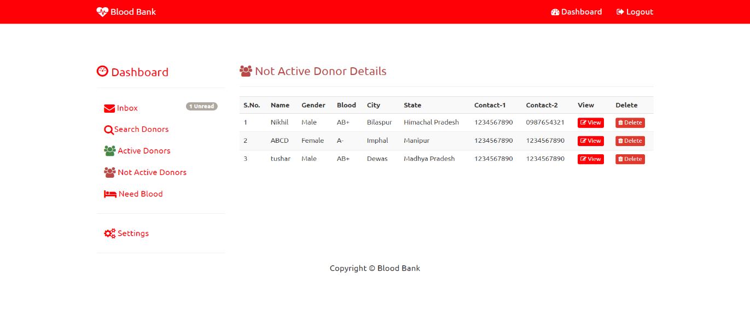

**Fig. 4.7: Non-Active Donor Page**

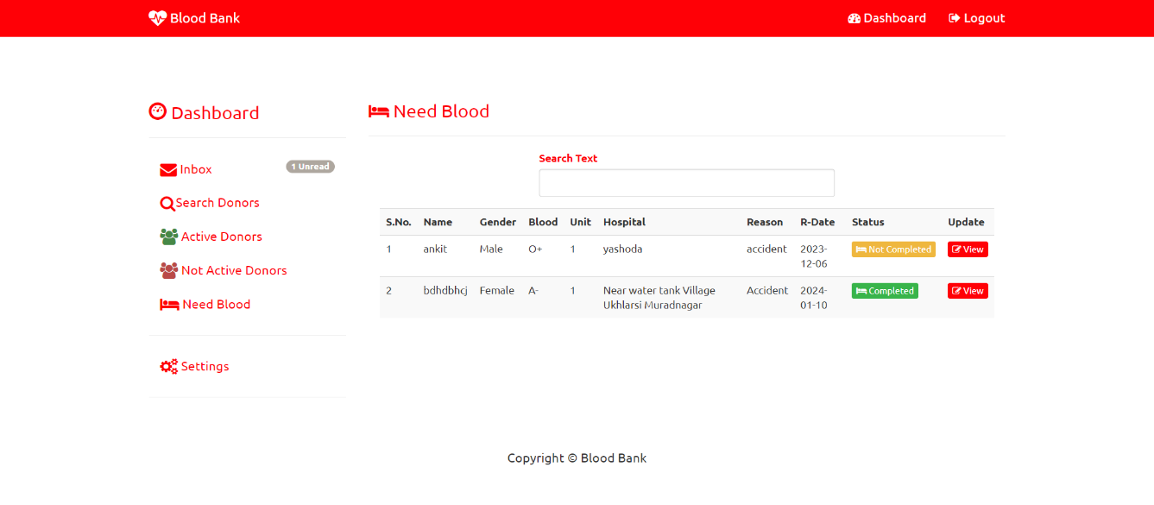**Fig. 4.8: Need Blood Page**

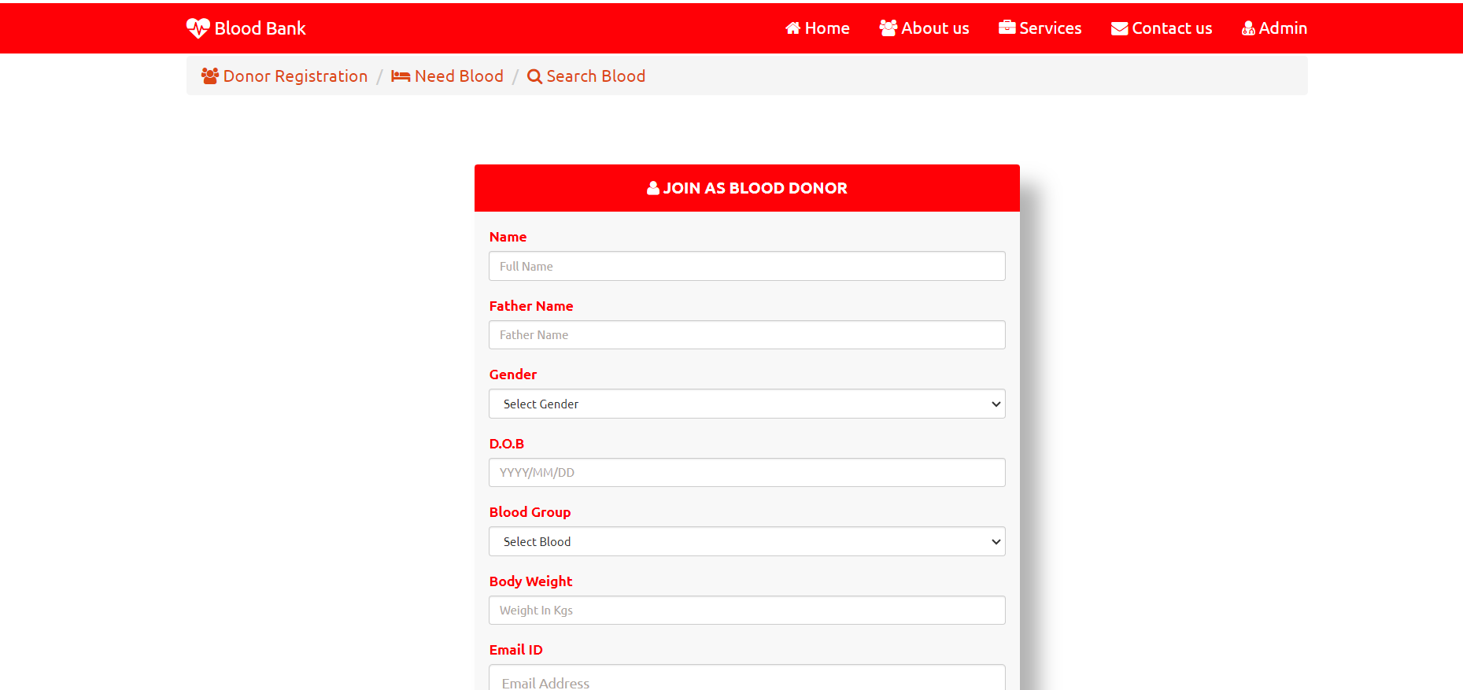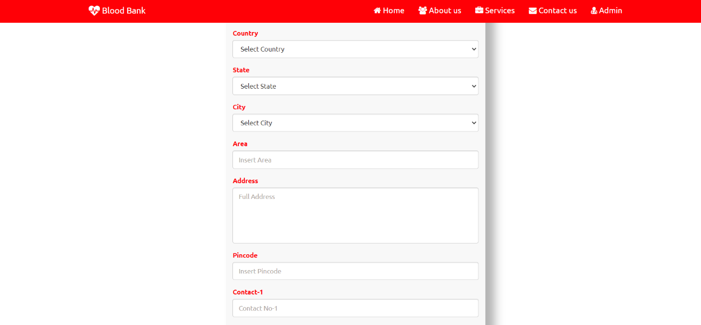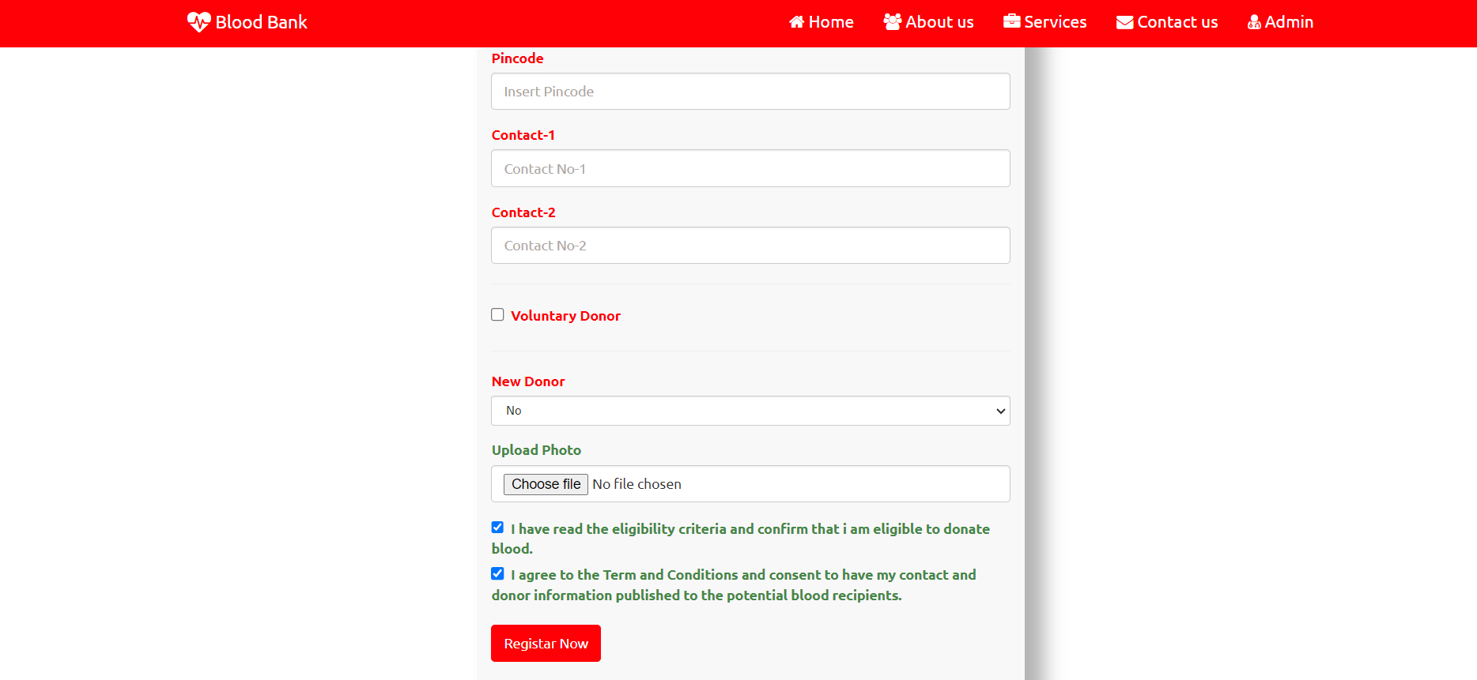

**Fig. 4.9: New Donor Registration Page**

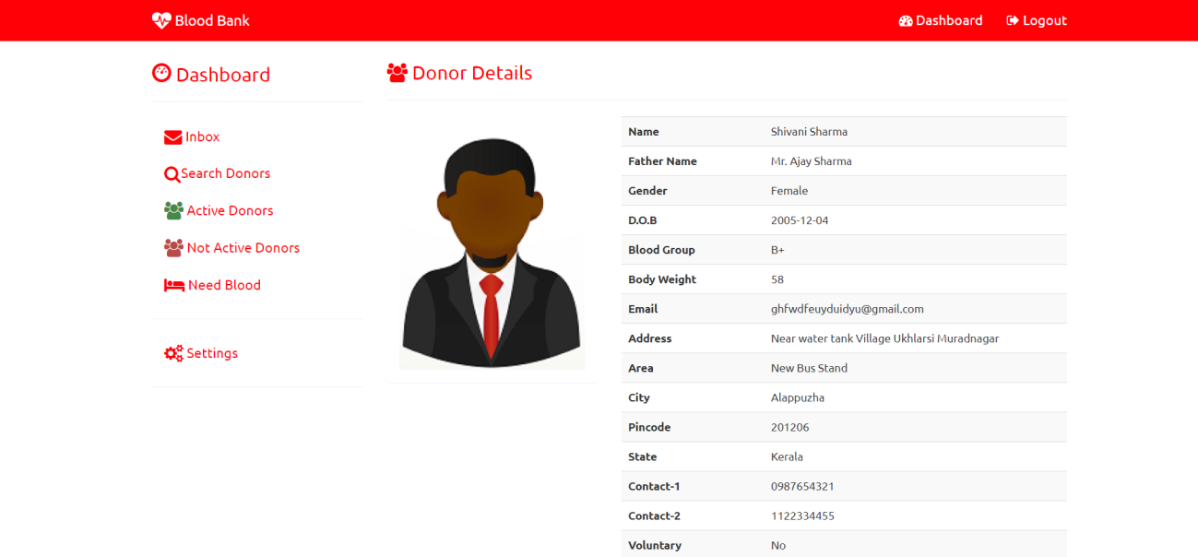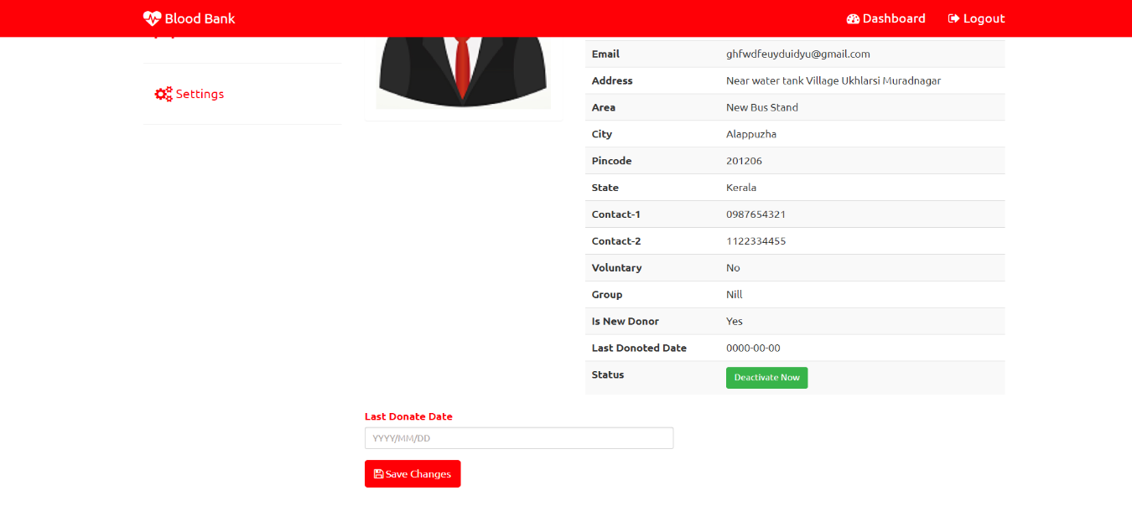

**Fig. 4.10: Donor Details Page**

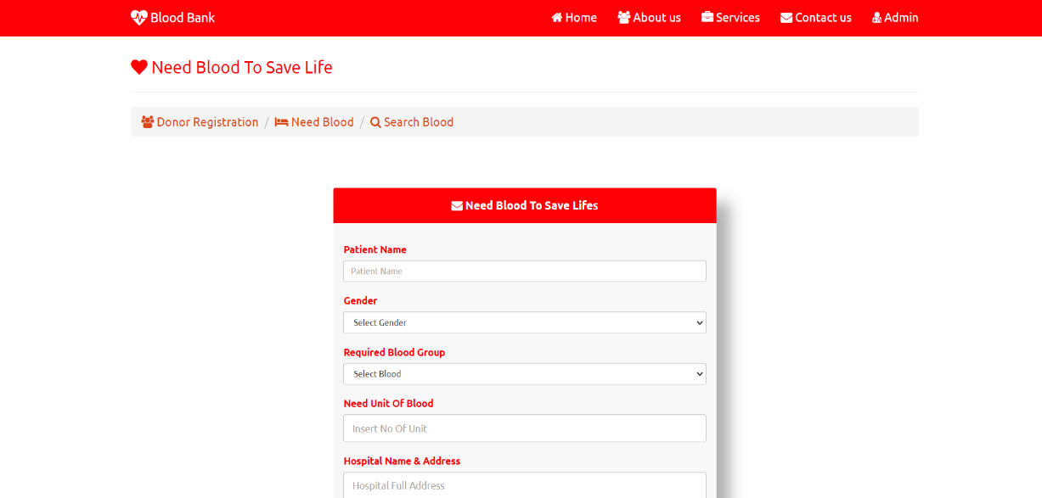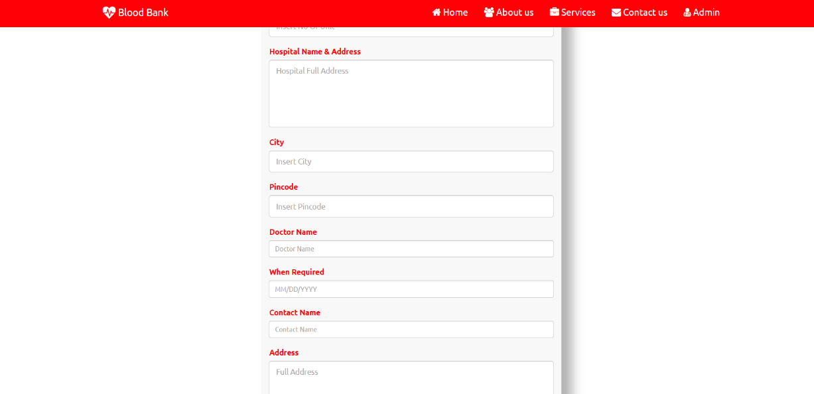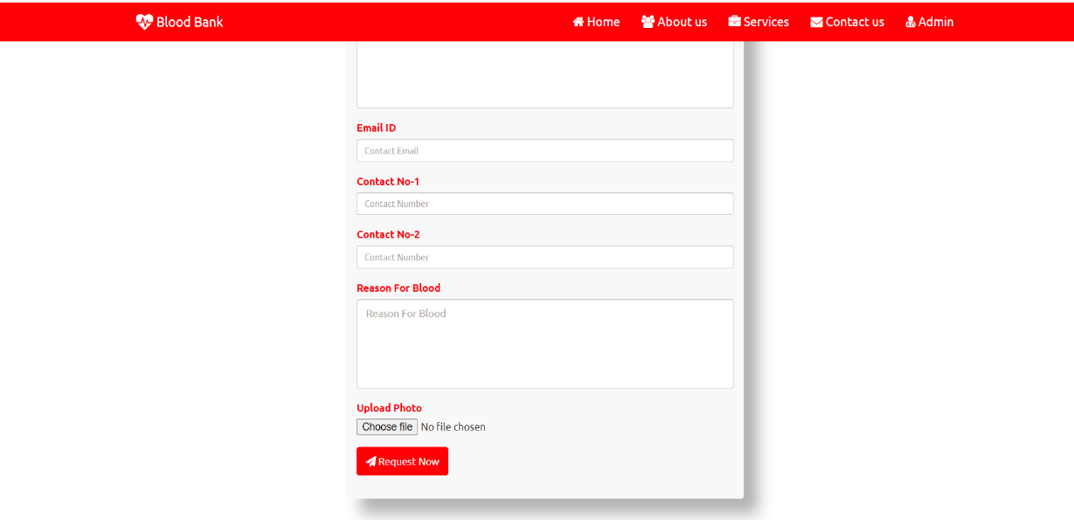 **Fig. 4.11: Need Blood Page**

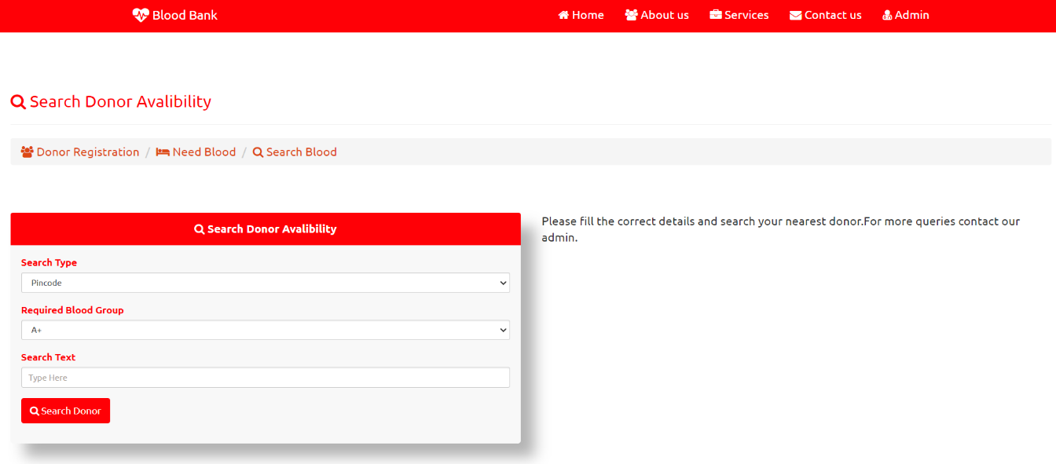

**Fig. 4.12:Donor Avability Page**

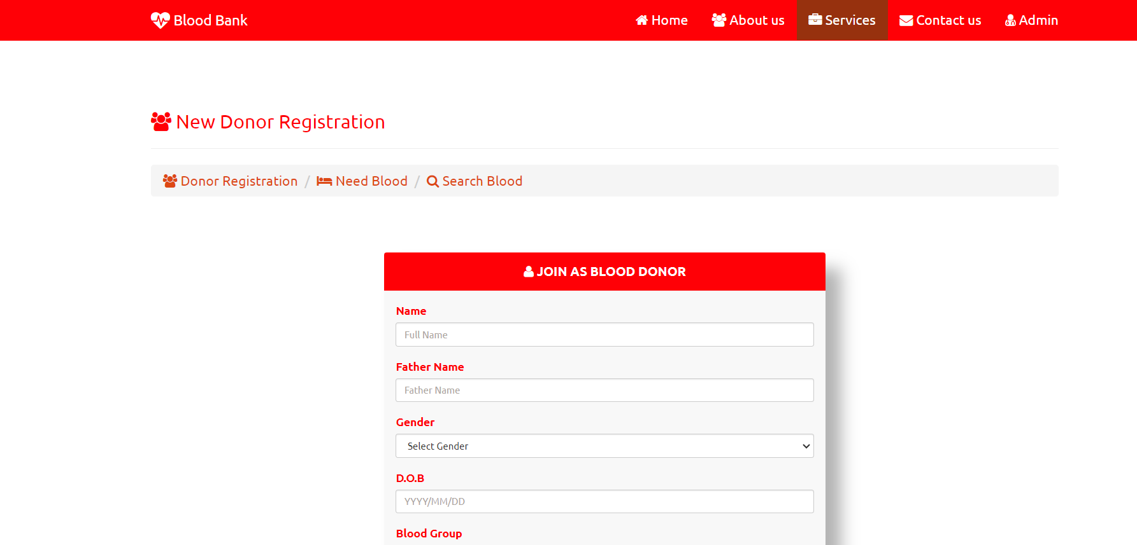

**Fig. 4.13: Service Page**

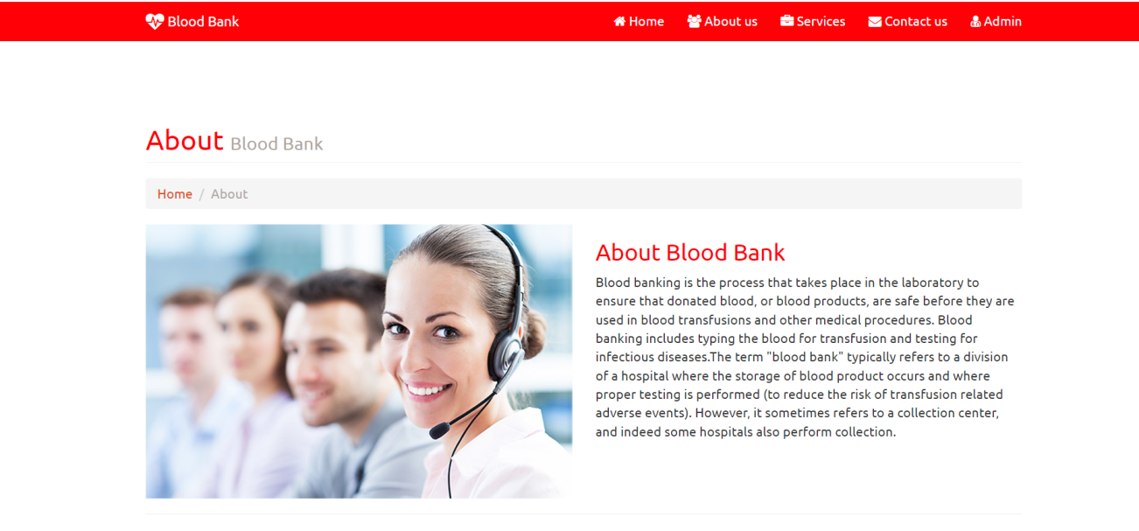**Fig. 4.14: About Page**

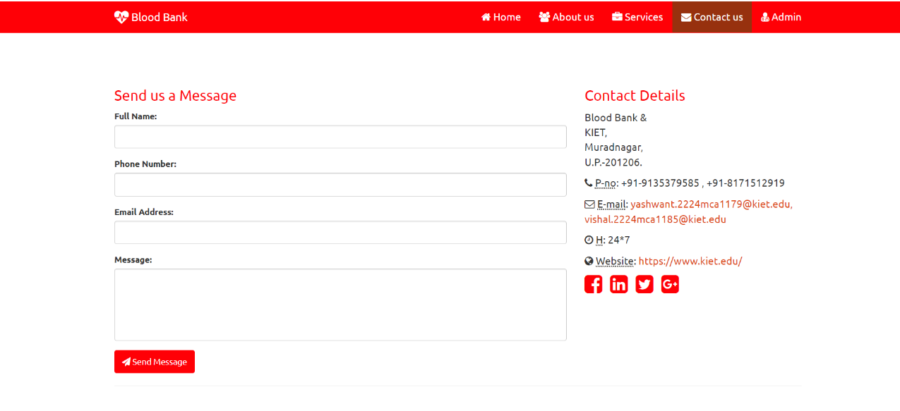**Fig. 4.15: Contact**

**CHAPTER 5**

**TESTING**

The testing phase of the Blood Donation Project is a critical stage in ensuring the reliability, functionality, and security of the developed software. Testing involves systematically evaluating each component, feature, and interaction within the system to identify and rectify any issues that may compromise the project's success. This introduction outlines the key objectives, methodologies, and principles guiding the testing process.

**5.1 Key Objectives:**

The key objective of a blood donation project is to ensure a safe, sustainable, and sufficient blood supply through the voluntary and regular contribution of blood from eligible donors. The primary goals include:

**5.1.1Verification of Functionality:**

Confirm that each feature and module of the Blood Donation Project functions according to the specified requirements. This includes user interfaces, data processing, and interaction workflows.

**5.1.2 Identification and Resolution of Bugs:**

Systematically identify and address any bugs or discrepancies within the codebase. Conduct thorough testing to ensure a robust and error-free software system.

**5.1.3 Usability Testing:**

Evaluate the user interfaces for usability and user-friendliness. Ensure that donors, organizers, healthcare professionals, and administrators can navigate the system easily and efficiently.

**5.1.4 Performance Testing:**

Assess the system's performance under various conditions, including peak loads and stress scenarios. Optimize code and configurations for responsiveness and scalability.

**5.1.5 Security Testing:**

Conduct rigorous security testing to identify vulnerabilities and potential exploits. Ensure that sensitive data, such as donor information and medical records, is protected through encryption and access controls.

**5.1.6 Compatibility Testing:**

Validate that the Blood Donation Project is compatible with different devices, browsers, and operating systems. Ensure a consistent and reliable experience across diverse platforms.

**5.1.7 Data Integrity and Database Testing:**

Verify the accuracy and integrity of data stored in the database. Test data retrieval and storage processes to guarantee reliability and consistency.

**5.2 Testing Methodologies:**

**5.2.1Unit Testing:**

Assess individual code units to ensure they perform as expected in isolation.

**5.2.2 Integration Testing:**

Evaluate the interactions between different components and modules to ensure seamless integration.

**5.2.3 System Testing:**

Verify the system as a whole to ensure that all components work together cohesively.

**5.2.4 Acceptance Testing:**

Validate that the Blood Donation Project meets the specified requirements and gains approval from stakeholders.

**5.3 Collaborative Testing:**

The testing phase involves collaboration among developers, quality assurance professionals, and end-users. Communication is crucial to understanding requirements, addressing issues, and refining the system iteratively.

**BIBLIOGRAPHY**

Creating a bibliography requires specific information about the sources you have used in your mini project. However, I can provide you with a sample bibliography for a blood donation mini project in India. Make sure to format it according to the citation style required by your instructor or institution (e.g., APA, MLA, Chicago). Here's an example in APA format:

* World Health Organization. (2017). Voluntary blood donation: Foundation of a safe and sufficient blood supply. Retrieved from

<https://www.who.int/bloodsafety/voluntary_donation/en/>

* Ministry of Health and Family Welfare, Government of India. (2020). National Blood Policy. Retrieved from

<https://www.mohfw.gov.in/sites/default/files/Chapter%206%20%20Blood%20Safety%20&%20Surveillance.pdf>

* Indian Red Cross Society. (n.d.). Blood donation. Retrieved from

<https://indianredcross.org/ircs/what-we-do/health/blood-services>

* National AIDS Control Organization. (2020). Blood safety & quality. Retrieved from

<http://naco.gov.in/blood-safety-quality>

* World Blood Donor Day. (2022). World Health Organization. Retrieved from

<https://www.who.int/campaigns/world-blood-donor-day/world-blood-donor-day-2022>

* Kumar, A., & Nair, P. S. (2018). Knowledge, Attitude, and Practices towards Voluntary Blood Donation among College Students in Rural India. Journal of Blood Transfusion, 2018, 9851089. <https://doi.org/10.1155/2018/9851089>
* Jain, A., Kaur, R., & Mehra, M. (2019). Knowledge, attitude, and practices about blood donation among adults in a semi-urban area in North India. Journal of Family Medicine and Primary Care, 8(5), 1709–1713. doi:10.4103/jfmpc.jfmpc_245_19
* Agrawal, A., & Tiwari, A. K. (2017). Knowledge, attitude, and practices of people toward voluntary blood donation in Uttarakhand. International Journal of Medicine and Public Health, 7(4), 240–243. doi:10.5530/ijmedph.2017.4.50.

**REFERENCE**

1. W3Schools.

https://www.w3schools.com/html/

1. Bootstrap Documentation.

https://getbootstrap.com/

1. Chatgpt

[https://chat.openai.com/](https://developer.mozilla.org/en-US/docs/Web/API/Document_Object_Model/Introduction)

1. Font Awesome Documentation.

[https://fontawesome.com/](https://fontawesome.com/v5.15/how-to-use/on-the-web/setup/getting-started)

1. Stack overflow

https://stackoverflow.com/